OBJECTIVE
Understanding and implementing the concept of concurrency through different mechanisms of multithreading.
Lab Task:
- Implement the following program on eclipse IDE and answer the following questions:
- How many threads are running?
3
- How many tasks are running?
3
- If more tasks are added than what will be the impact on number of threads?
If more tasks are added, the program will create more threads to execute them.
This increases parallel execution but may also raise CPU and memory usage.
- Explain the flow of program:
class Main extends Thread{
public void run(){
System.out.println("task one");
}
public static void main(String args[]){
Main t1=new Main();
Main t2=new Main();
Main t3=new Main();
t1.start();
t2.start();
t3.start();
}
}

Flow of the program:
- The class Main extends Thread, so each object (t1, t2, t3) represents a separate thread.
- When start() is called, each thread runs the run() method concurrently, printing "task one" (order of output may vary).
- With the help of threading print two tables concurrently, print one table number of student roll number e.g. 2019-SE-092 and second number should be date of birth e.g. 05-April.

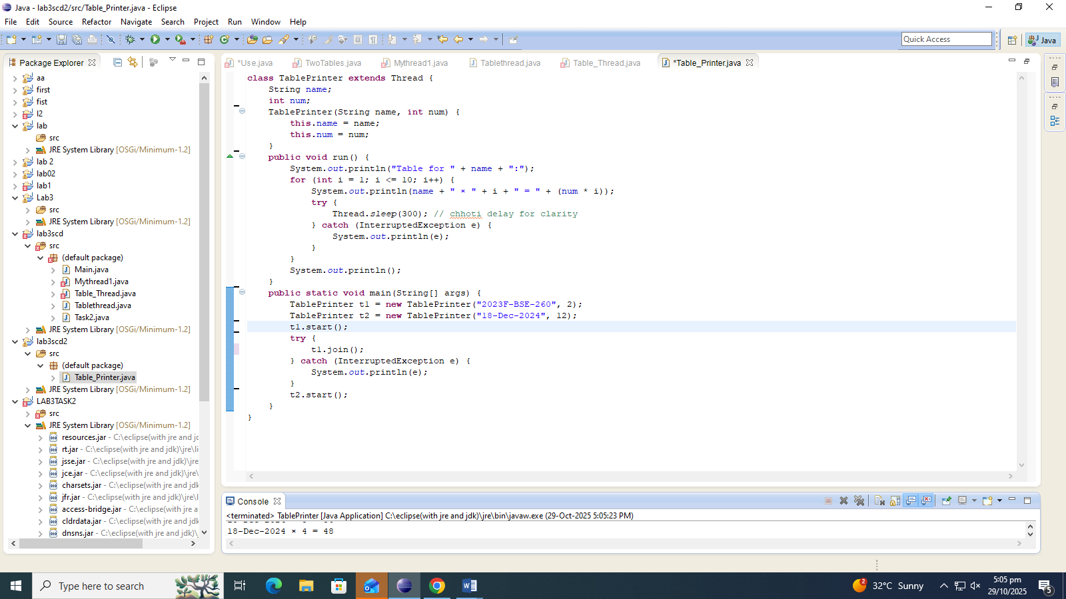
OUTPUT:

